A LONG WAY FROM HOME

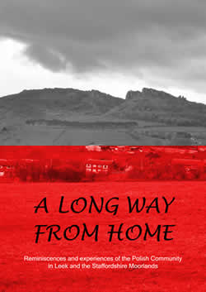
A Long Way From Home With the help of funding from Market Towns Initiative, in May 2004 Borderland Voices published the book of Polish reminiscence, 'A Long Way from Home'.
The book was launched at Leek Library and followed by a celebratory evening organised by the local Polish community.
To purchase a copy for £6 inclusive of p&p please e-mail us at: info@borderlandvoices.org.uk

